Lab 10

Experiment 3:

We did the cache controller

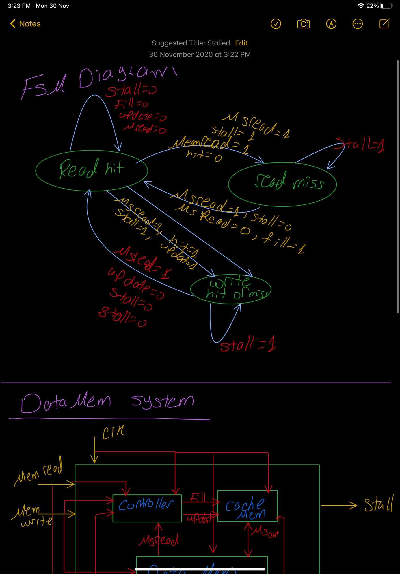

Experiment 4:

We did the data system memory module

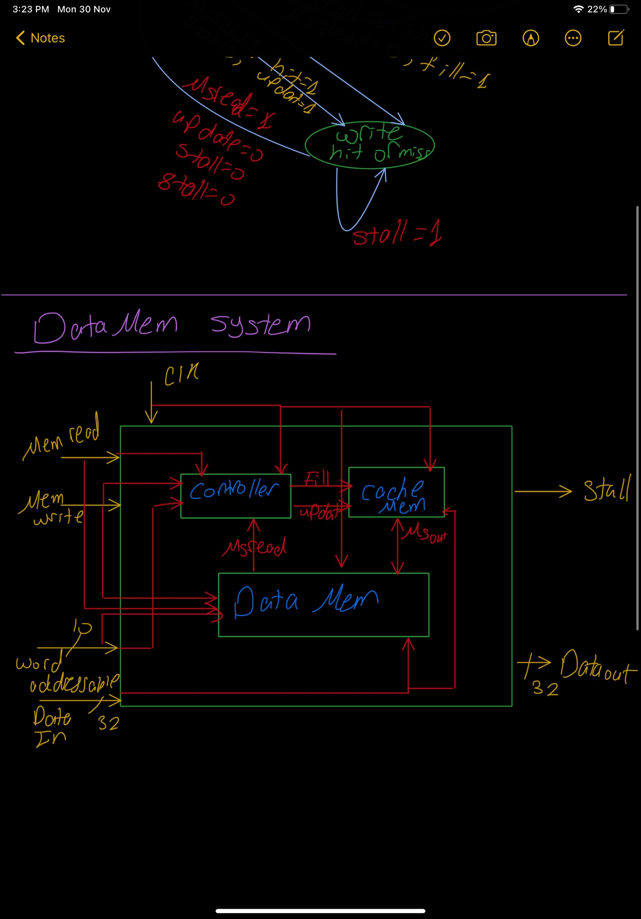

ScreenShots for simulation:

1)

These are the register file

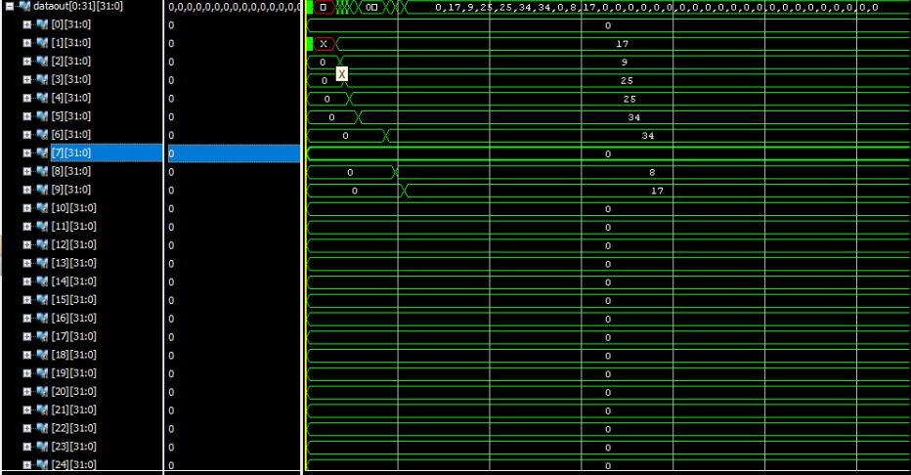

2)

There are the cache

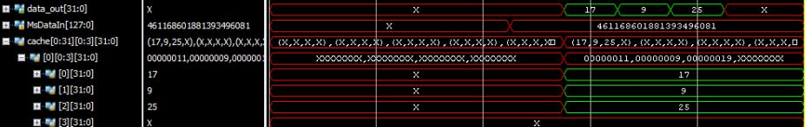

3) This is the stall signal and the PC results

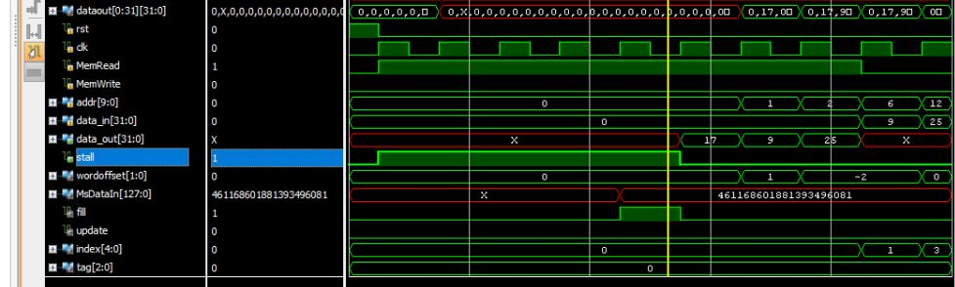

4)

